**DAILY ONLINE ACTIVITIES SUMMARY**

|  |  |  |  |  |  |  |  |
| --- | --- | --- | --- | --- | --- | --- | --- |
| **Date:** | **1/06/20** | | | | **Name:** | **Namratha C** | |
| **Sem & Sec** | **8th sem, A sec** | | | | **USN:** | **4AL16CS056** | |
| **Online Test Summary** | | | | | | | |
| **Subject** | | **SMS** | | | | | |
| **Max. Marks** | | **60** | | **Score** | | **60** | |
| **Certification Course Summary** | | | | | | | |
| **Course** | **Aws Development Tools services Overview** | | | | | | |
| **Certificate Provider** | | | **Aws training and certification** | **Duration** | | | **5 mins** |
| **Coding Challenges** | | | | | | | |
| **Problem Statement: 1) Program to print ASCII value.**  **.** | | | | | | | |
| **Status: Completed** | | | | | | | |
| **Uploaded the report in Github** | | | | **Yes** | | | |
| **If yes Repository name** | | | | **CODES (Namrathasonu)** | | | |
| **Uploaded the report in slack** | | | | **Yes** | | | |

Online Test Details:

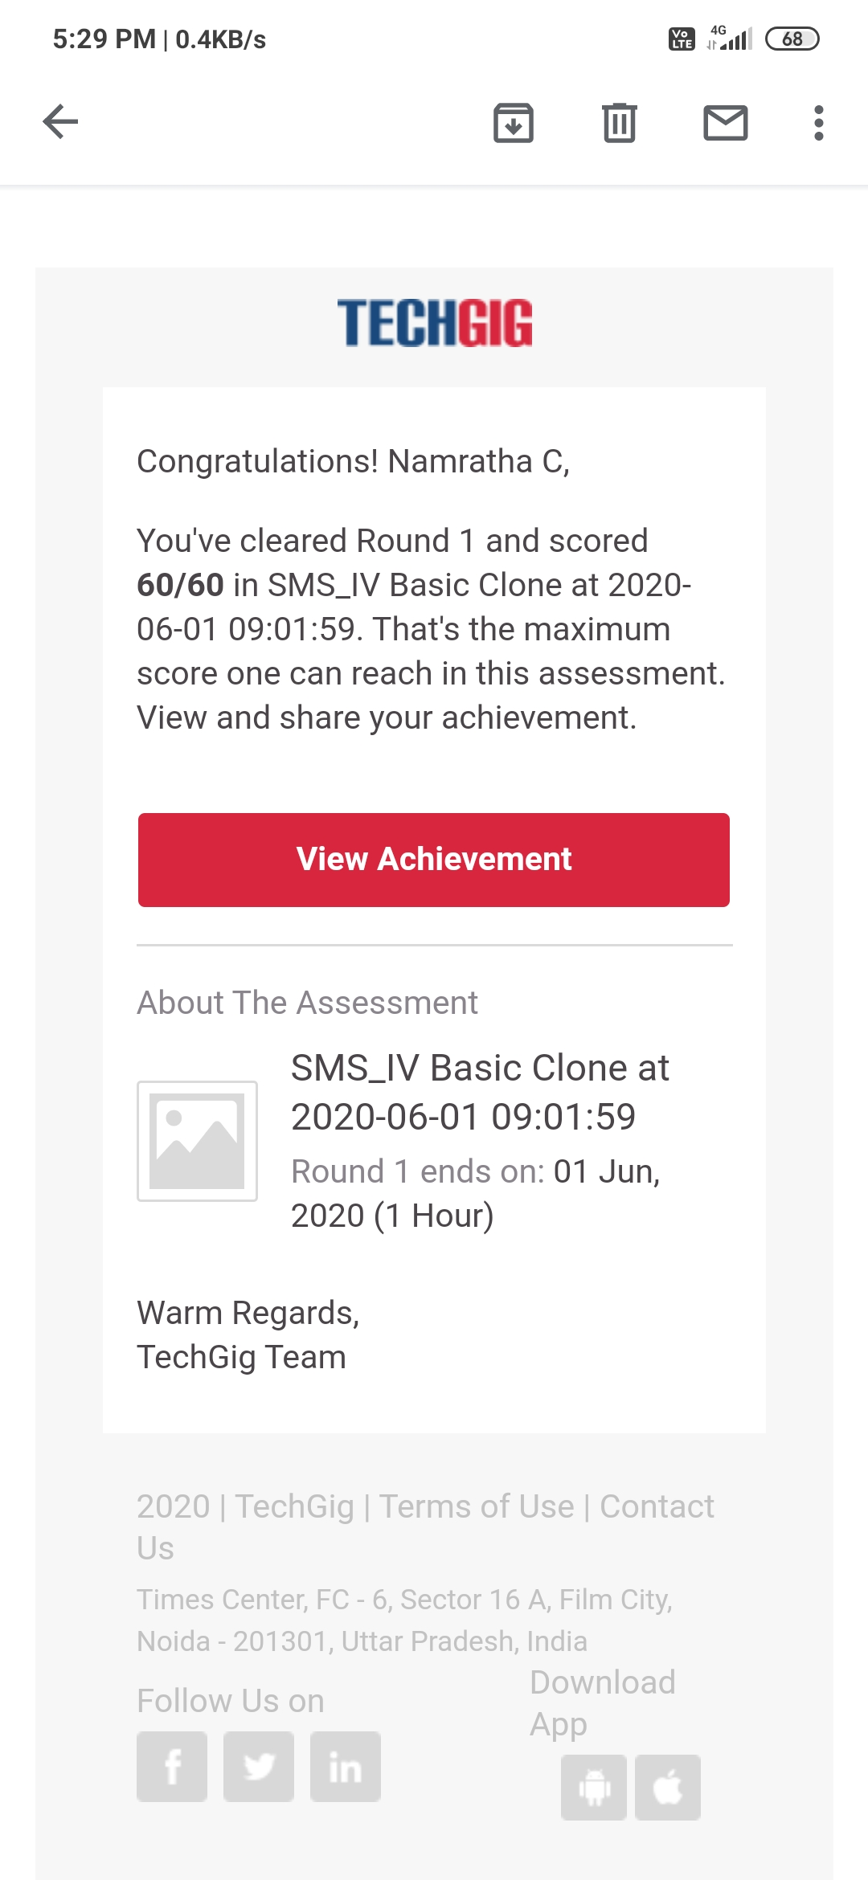

The test was on the subject System Modelling Simulation.

Certification Course Details:

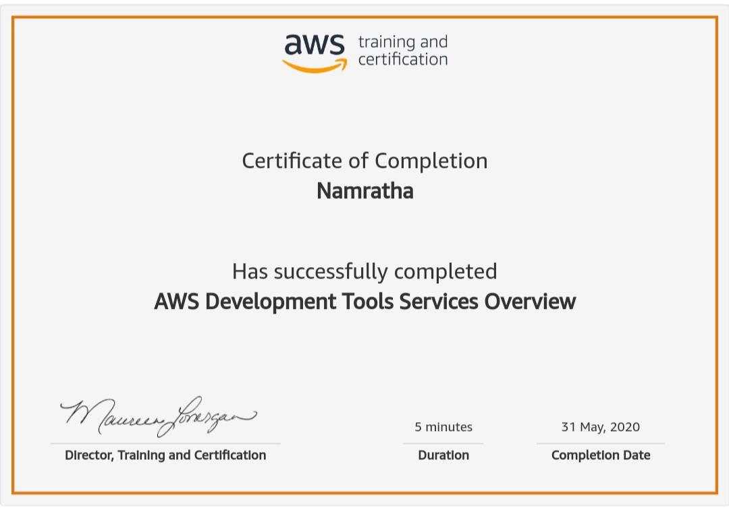

Coding Challenges Details:

1)

#include <stdio.h>

int main() {

char c;

printf("Enter a character: ");

scanf("%c", &c);

// %d displays the integer value of a character

// %c displays the actual character

printf("ASCII value of %c = %d", c, c);

return 0;

}